Artificial Intelligence

UNIT-II
Heuristic Search Techniques

Heuristic Search Techniques
Topics to discuss:
- Issues in The Design of Search Programs
- Generate-And- Test
- Hill Climbing and its variants
- Best-First Search
- A* Algorithm
- Problem Reduction
- AO*Algorithm
- Constraint Satisfaction
- Means-Ends Analysis
Text Books:
- Artificial Intelligence, Elaine Rich and Kevin Knight, Tata McGraw -Hill
Publications
- Introduction To Artificial Intelligence & Expert Systems, Patterson, PHI Publications

Heuristic Search Techniques
  - Good solution to hard problems
  - Very large search space
    - Large databases
    - Image sequences
    - Game playing
  - Algorithms
    - Guaranteed best answer
    - Can be slow – literally years
  - Heuristics
    - “Rules of thumb”
    - Very fast
    - Good answer likely, but not guaranteed!
  - Searching foreign intelligence for terrorist activity.

- Heuristic algorithms are not really intelligent; they appear to be intelligent because they achieve better performance.
- Heuristic algorithms are more efficient because they take advantage of feedback
from the data to direct the search path.
- Uninformed search algorithms or Brute-force algorithms, search through the search space all possible candidates for the solution checking whether each candidate satisfies the problem‟s statement.
- Informed search algorithms use heuristic functions that are specific to the problem, apply them to guide the search through the search space to try to reduce the amount of time spent in searching.
- A good heuristic will make an informed search dramatically outperform any uninformed search: for example,
- The Traveling Salesman Problem (TSP), where the goal is to find is a good solution instead of finding the best solution.
- In such problems, the search proceeds using current information about the problem to predict which path is closer to the goal and follows it, although it does not always guarantee to find the best possible solution.
- Such techniques help in finding a solution within reasonable time and space (memory).
- Some prominent intelligent search algorithms are stated below: 1. Generate and Test Search 2. Best-first Search 3. Greedy Search 4. A* Search 5. Constraint Search 6. Means-ends analysis

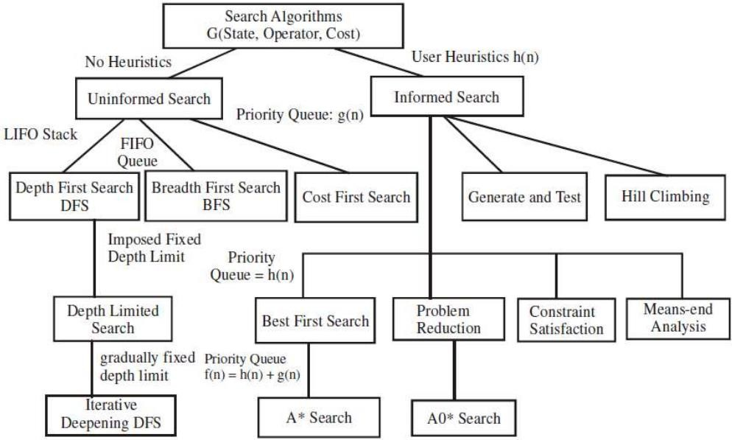

Generate and Test Search
Generate and Test Search is a heuristic search technique based on Depth First Search with Backtracking which guarantees to find a solution if done systematically and there exists a solution. In this technique, all the solutions are generated and tested for the best solution. It ensures that the best solution is checked against all possible generated solutions.

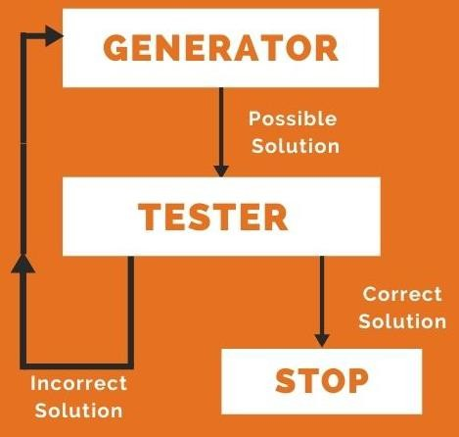
Algorithm
- Generate a possible solution. For example, generating a particular point in the problem space or generating a path for a start state.
- Test to see if this is a actual solution by comparing the chosen point or the endpoint of the chosen path to the set of acceptable goal states
- If a solution is found, quit. Otherwise go to Step 1

Hill Climbing

Algorithm: Hill Climbing
  - Evaluate the initial state.
  - Loop until a solution is found or there are no new operators left to be applied:
    - Select and apply a new operator
    - Evaluate the new state:
      - goal -→ quit
      - better than current state -→ new current state

- Hill Climbing technique can be used to solve many problems, where the current state allows for an accurate evaluation function, such as Network-Flow, Travelling Salesman problem, 8-Queens problem, Integrated Circuit design, etc.
- Like DFS
- Optimization technique based on local searches Can be used to solve problems that have many solutions
- TSP can solved moving through a tree of paths, hill climbing
proceeds in DFS order.
- Search may reach to a position i.e. a solution but from there no move improves the situation
  - Local maximum: a state better than all but not better than some other states which are away
  - Plateau: search space where all neighboring states has the same value
  - Ridge: search space that is higher than surrounding areas

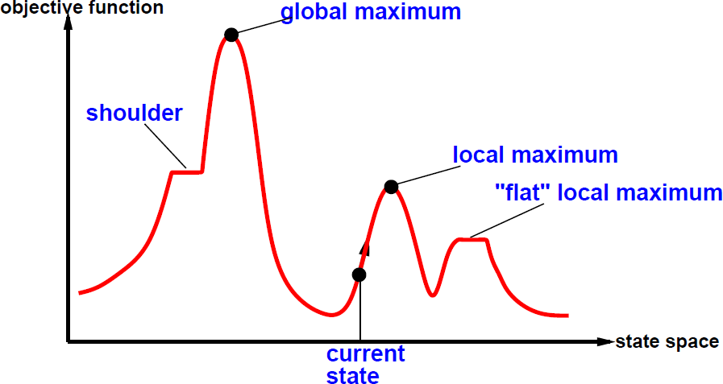

- Local maximum = no uphill step
  - not complete
– Allow “random restart” which is complete, but might take a very long time
- Plateau = all steps equal (flat or shoulder)
– Must move to equal state to make progress, but no indication of the correct direction

Hill Climbing Algorithm
We will assume we are trying to maximize a function. That is, we are trying to find a point in the search space that is better than all the others. And by "better" we mean that the evaluation is higher. We might also say that the solution is of better quality than all the others.
The idea behind hill climbing is as follows.
- Pick a random point in the search space.
- Consider all the neighbours of the current state.
- Choose the neighbour with the best quality and move to that state.
- Repeat 2 thru 4 until all the neighbouring states are of lower quality.
- Return the current state as the solution state.

Types of Hill Climbing Algorithm:
- Simple hill Climbing:

Steepest-Ascent hill-climbing:
- Stochastic hill Climbing:

Algorithm for Simple Hill Climbing:
- Step 1: Evaluate the initial state, if it is goal state then return success and Stop.
- Step 2: Loop Until a solution is found or there is no new operator left to apply.
- Step 3: Select and apply an operator to the current state.
- Step 4: Check new state:
  - If it is goal state, then return success and quit.
  - Else if it is better than the current state then assign new state as a current state.
  - Else if not better than the current state, then return to step2.
- Step 5: Exit.

This algorithm has the following features:
- Less time consuming
- Less optimal solution and the solution is not guaranteed

Steepest-Ascent hill climbing:
The steepest-Ascent algorithm is a variation of simple hill climbing algorithm. This algorithm examines all the neighbouring nodes of the current state and selects one neighbour node which is closest to the goal state. This algorithm consumes more time as it searches for multiple neighbours
Algorithm for Steepest-Ascent hill climbing:

- Step 1: Evaluate the initial state, if it is goal state then return success and stop, else make current state as initial state.
- Step 2: Loop until a solution is found or the current state does not change.
  - Let SUCC be a state such that any successor of the current state will be better than it.
  - For each operator that applies to the current state:
    - Apply the new operator and generate a new state.
    - Evaluate the new state.
    - If it is goal state, then return it and quit, else compare it to the SUCC.
    - If it is better than SUCC, then set new state as SUCC.
    - If the SUCC is better than the current state, then set current state to
SUCC.
- Step 5: Exit.

Stochastic hill climbing:
- Stochastic hill climbing does not examine for all its neighbour before moving. Rather, this search algorithm selects one neighbour node at random and decides whether to choose it as a current state or examine another state.

Best First Search (Informed Search)
Algorithm:
Best-First-Search(Graph g, Node start)
- Create an empty PriorityQueue pq;
- pq.insert(start) // Insert "start" in pq
- While PriorityQueue is not empty do
  - u = PriorityQueue.DeleteMin
  - if u is the goal state, then Exit
  - Else
  - For each neighbour v of u
    - If v "Unvisited“ then Mark v "Visited"
    - pq.insert(v)
  - Mark v "Examined"
- End procedure

A General Example

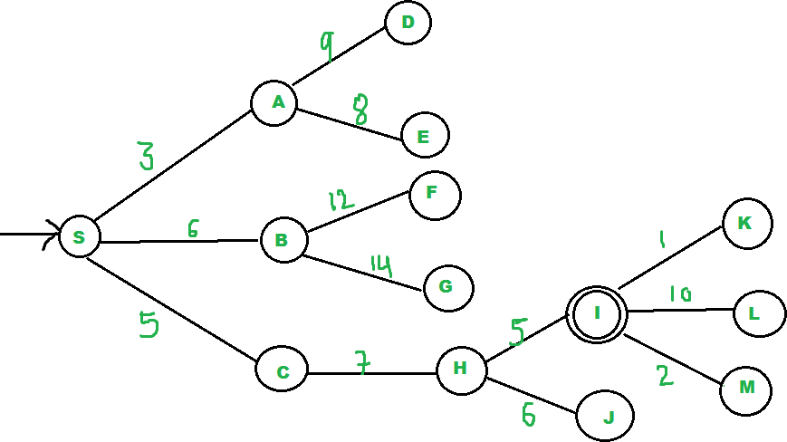

Best-first search
- use an evaluation function f(n) for each node
  - f(n) provides an estimate for the total cost
  - Expand the node n with smallest f(n).
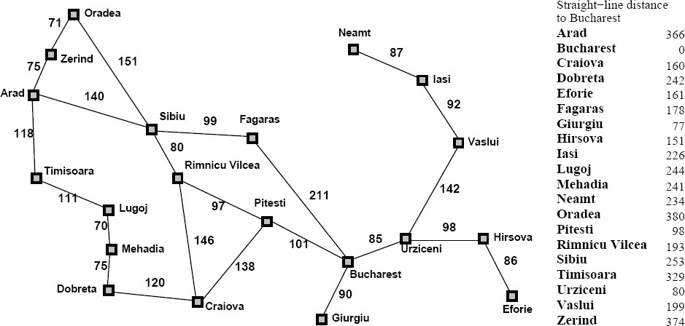


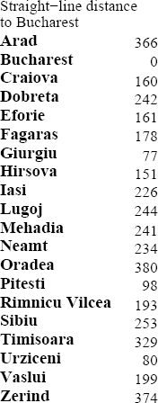
Start node: Arad
Goal node: Bucharest

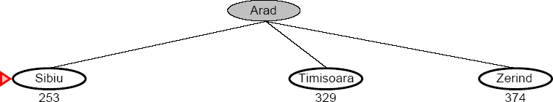

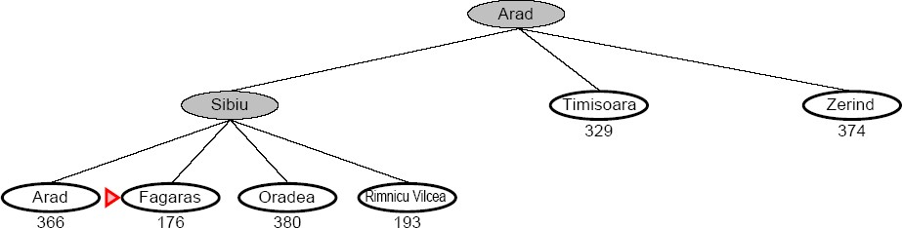

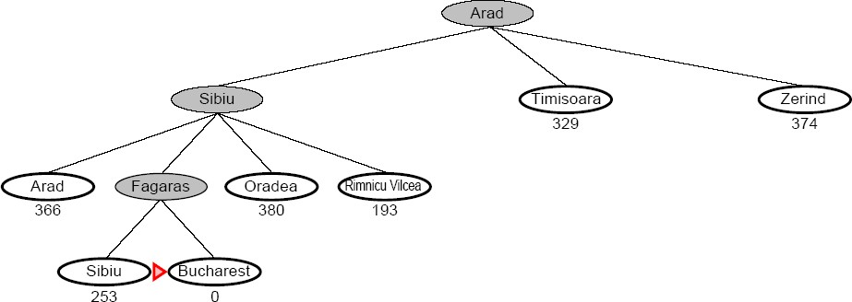
Total distance covered:
140+99+211=450

Complete
  - No, GBFS can get stuck in loops (e.g. bouncing back and forth between cities)

Time
  - O(b^{m}) but a good heuristic can have dramatic improvement

Space
  - O(b^{m}) – keeps all the nodes in memory

Optimal
  - No!

A* Search
- A* (A star) is the most widely known form of Best-First search
  - It evaluates nodes by combining g(n) and h(n)
– f(n) = g(n) + h(n)
  - Where
    - g(n) = the actual cost to get from the initial node to node n.
    - h(n) = Heuristic cost (also known as "estimation cost") from node n to destination node n.

- Create an open list of found but not explored nodes, initially empty.
- Create a closed list to hold already explored nodes, initially empty.
- Add a starting node to the open list with an initial value of g
- While the open list is not empty do
  - find the node with the least value of f() on the open list, call it „q‟
  - Remove „q‟ from the open list
  - generate q's successors and set their parents to q
  - for each successor
    - if successor is the goal state, then stop search
    - else, compute g(), h(), and f() for successor
    - if a node with the same level as successor is in the OPEN list which has a lower f than successor, skip this successor
    - else if a node with the same level as successor is in the CLOSED list which has a lower f than successor, skip this successor
    - else, add the node to the open list
  - Insert q on to the closed list

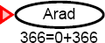
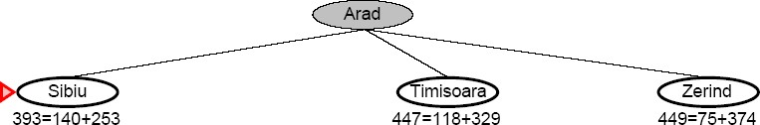
140
75
118

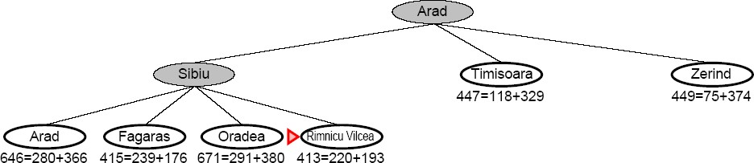
140
75
118

140
99 151 80

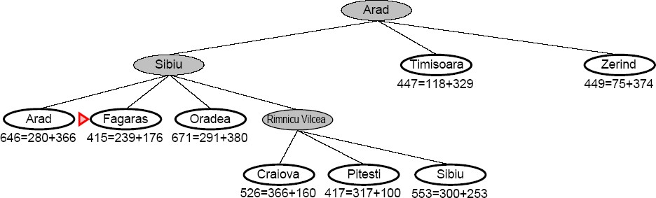
140
75
118
80
140
99
151
146
97
80

140 99 151 80
140 118 75

99 211
146 97 80

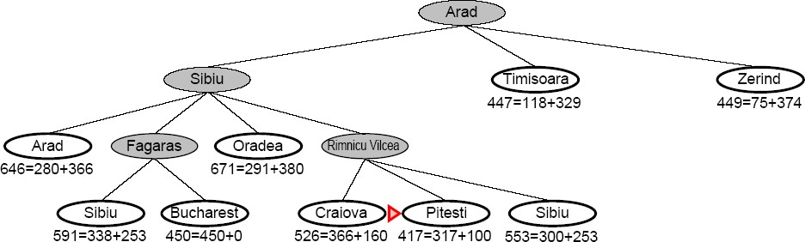
Node will be skipped as per algo.

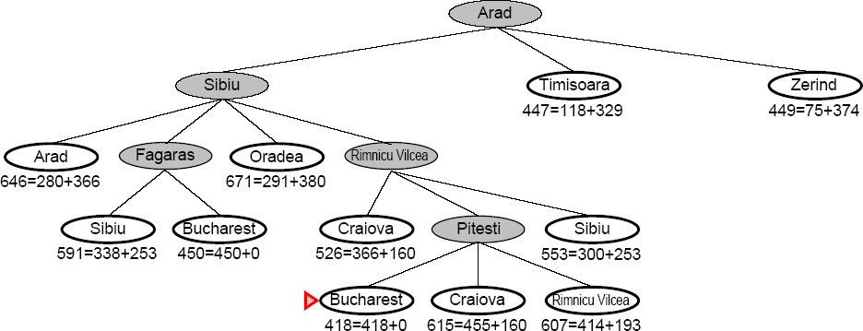
140

140 99 151 80

118 75

80
99 146 97
211

Skipped

101 138 97

- Complete
  - Yes
- Time
  - Exponential
  - The better the heuristic, the better the time
    - Best case h is perfect, O(d)
    - Worst case h = 0, O(b^{d}) same as BFS
- Space
  - Keeps all nodes in memory and save in case of repetition
  - This is O(b^{d}) or worse
  - A* usually runs out of space before it runs out of time
- Optimal
  - Yes

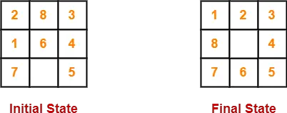

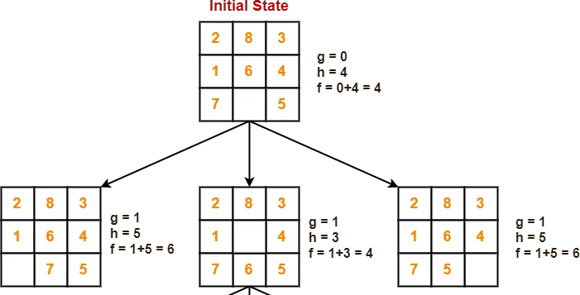

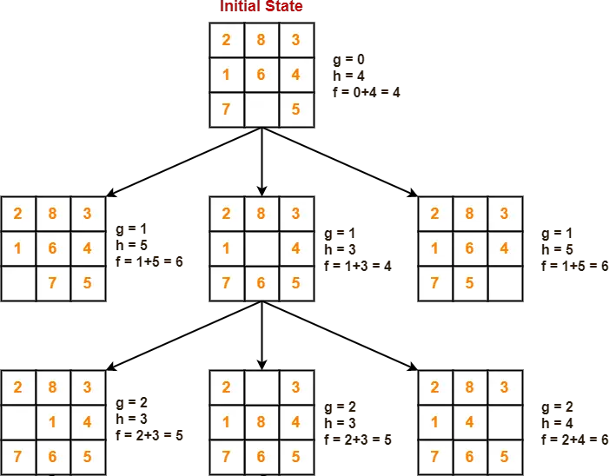

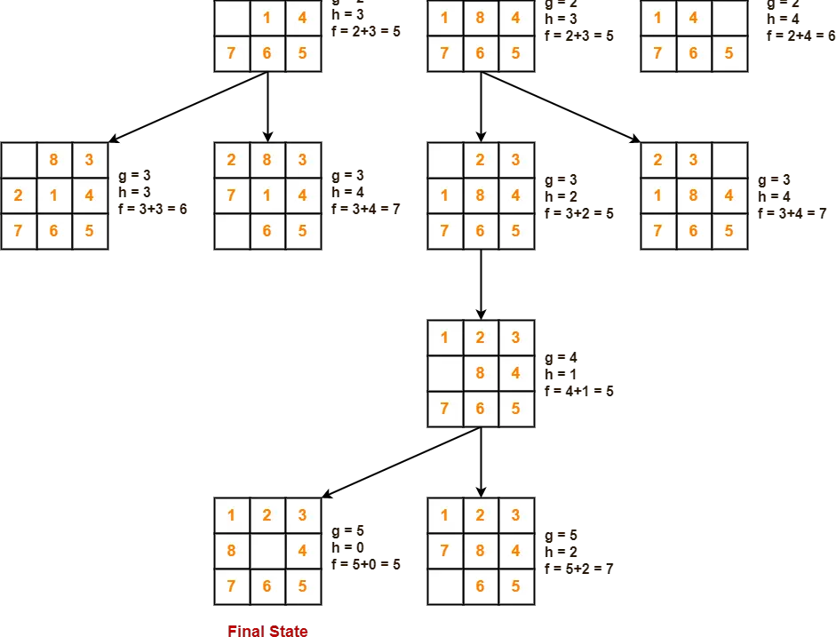

Problem Reduction
- If we are looking for a sequence of actions to achieve some goal, then one way to do it is to use state-space search, where each node in you search space is a state of the world, and you are searching for a sequence of actions that get you from an initial state to a final state.
- Another way is to consider the different ways that the goal state can be decomposed into simpler sub-goals.
- If we can discover how to get from a given node to a goal state along any one of the branches leaving it.
- To represent problem reduction techniques we need to use an AND-OR graph/tree.
- Problem reduction technique using AND-OR graph is useful for representing a solution of a problems that can be solved by decomposing them into a set of smaller problems all of which must be solved.

- This decomposition or reduction generates arcs that we call AND arcs.
- One AND arc may point to any numbers of successor nodes.
- All of which must then be solved in order for the arc to point
solution.
- In order to find solution in an AND-OR graph we need an algorithm similar to best-first search but with the ability to handle the AND arcs appropriately.
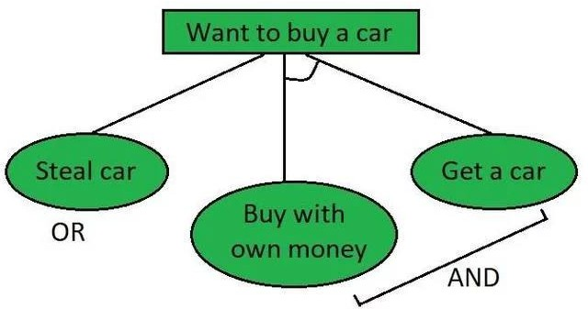
- We define FUTILITY, if the estimated cost of solution becomes greater than the value of FUTILITY then we abandon the search, FUTILITY should be chosen to correspond to a threshold.

38
A

Better

5

path is B

3 4
9
C
A
D
B

rather
17
F
B
E
9 27

choosing C and D
F
C
G
D
I
H
5 10 3 4 15 10

Problem Reduction algorithm:
- Initialize the graph to the starting node.
- Loop until the starting node is labelled SOLVED or until its cost goes
above FUTILITY:
  - Traverse the graph, starting at the initial node and following the current best path and accumulate the set of nodes that are on that path and have not yet been expanded or labelled as solved.
  - Pick one of these unexpanded nodes and expand it. If there are no successors, assign FUTILITY as the value of this node. Otherwise, add its successors to the graph and for each of them compute f'(n). If f'(n) of any node is 0, mark that node as SOLVED.
  - Change the f'(n) estimate of the newly expanded node to reflect the new information provided by its successors. Propagate this change backwards through the graph. If any node contains a successor arc whose descendants are all solved, label the node itself as SOLVED.

AO*Algorithm

Difference between the A* Algorithm and AO* algorithm
- A* algorithm and AO* algorithm both works on the best first search.
- They are both informed search and works on given
heuristics values.
- A* always gives the optimal solution but AO* doesn‟t guarantee to give the optimal solution.
- Once AO* got a solution doesn’t explore all possible paths but A* explores all paths.
- When compared to the A* algorithm, the AO* algorithm uses less memory.
- Opposite to the A* algorithm, the AO* algorithm cannot go into an endless loop.

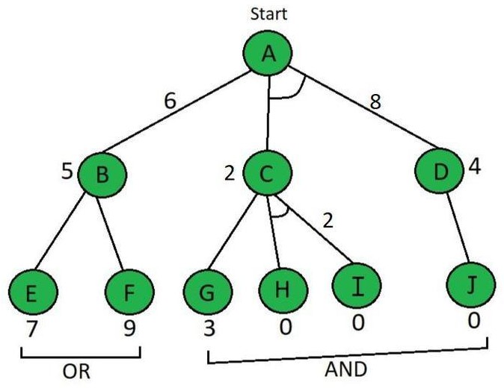

Start from node A, f(A⇢B) = g(B) + h(B) = 1 + 5 ……here g(n)=1 is taken by default for path cost = 6 f(A⇢C+D) = g(c) + h(c) + g(d) + h(d) = 1 + 2 + 1 + 4
……here we have added C & D because they are in AND = 8 So, by calculation A⇢B path is chosen which is the minimum path, i.e f(A⇢B)

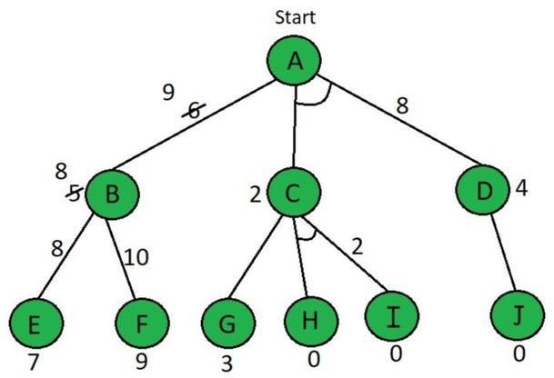

explore node B Here the value of E & F are calculated as follows, f(B⇢E) = g(e) + h(e) f(B⇢E) = 1 + 7 = 8 f(B⇢f) = g(f) + h(f) f(B⇢f) = 1 + 9 = 10
B's heuristic value is different from its actual value The heuristic is updated and the minimum cost path is selected.
f(A⇢B) = g(B) + updated h(B) = 1 + 8 = 9

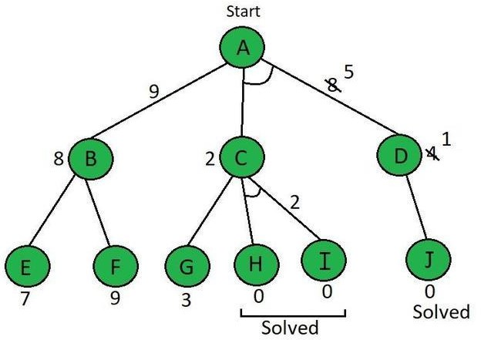

By comparing f(A⇢B) & f(A⇢C+D) f(A⇢C+D) is shown to be
smaller, i.e. 8 < 9
Now explore f(A⇢C+D)
So, the current node is C f(C⇢G) = g(g) + h(g) f(C⇢G) = 1 + 3 = 4
f(C⇢H+I) = g(h) + h(h) + g(i) + h(i) f(C⇢H+I) = 1 + 0 + 1 + 0 = 2
f(C⇢H+I) is selected as the path with the lowest cost and the heuristic is also left unchanged because it matches the actual cost. Paths H & I are solved because the heuristic for those paths is 0
Path A⇢D needs to be calculated because it has an AND. f(D⇢J) = g(j) + h(j) f(D⇢J) = 1 + 0 = 1 the heuristic of node D needs to be updated to 1.
f(A⇢C+D) = g(c) + h(c) + g(d) + h(d) = 1 + 2 + 1 + 1 = 5
path f(A⇢C+D) is get solved and this tree has become a
solved tree now.

Constraint satisfaction problems (CSPs)
Goal is to solve some problem state that satisfies a given set of constraints instead of finding optimal path to the solution state.
Applications Cryptarithmetic Problem N-Queen problem
Map coloring problem

Example: Map-Coloring
- Variables: set of nodes/regions
- Domains Di = {red, green, blue}
- Constraints: adjacent regions must have different colors
- Start state: all variables are unassigned
- Goal state: assigned values which satisfy constraints
- Operator: assigns values to any unassigned variable, provided not conflict with previous assigned variables.

Constraint Satisfaction Problem
The general form of the constraint satisfaction procedure is as
follows:
Until a complete solution is found or until all paths ends, do
- Select an unexpanded node of the search graph.
- Apply the constraint inference rules to the selected node to generate all possible new constraints.
- If the set of constraints contains a contradiction, then report
that this path is a dead end.
- If the set of constraints describes a complete solution then report success.
- If neither a constraint nor a complete solution has been found then apply the rules to generate new partial solutions. Insert these partial solutions into the search graph.

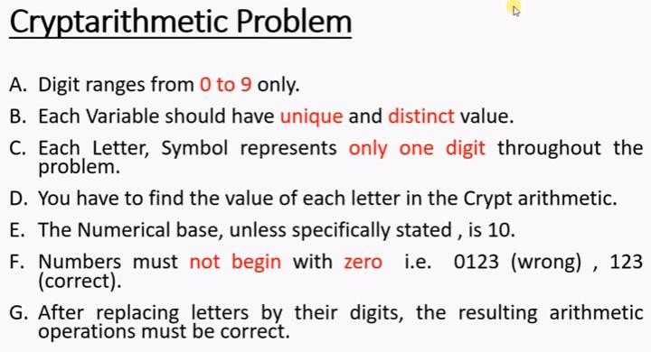
CONSTRAINTS:-

  - Initial state of problem.
  - D=?
  - E=?
  - Y=?
  - N=?
  - R=?
  - O=?
  - S=?
  - M=?

SEND
+ MORE
------------ MONEY
------------

  - C1,C2,C3 stands for the carry variables respectively
  - Goal State: The digits to the letters must be assigned in such
a manner so that the sum is satisfied.

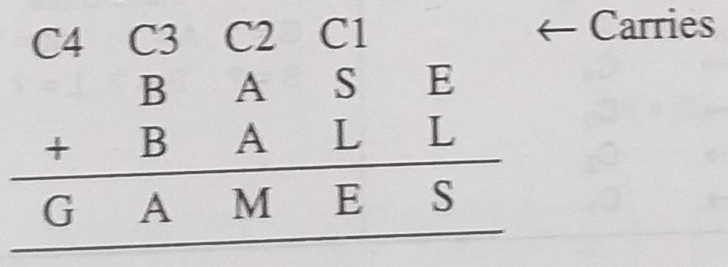

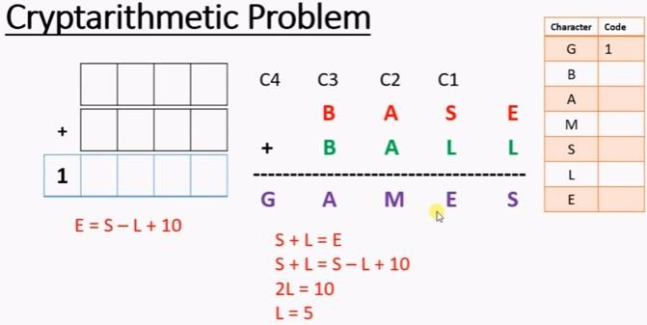
Since E+L = S
i.e. E = S-L

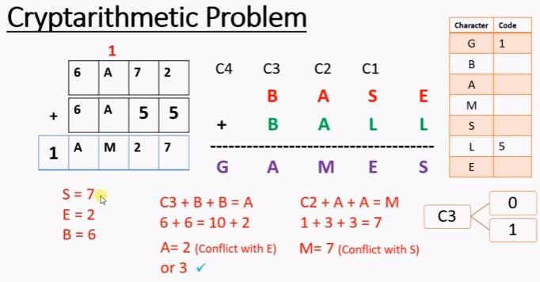
Consider
C3=0 or 1
C2=1

S-E=5
M Conflict with B i.e. 6
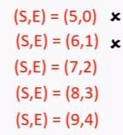
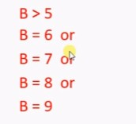
Since C4 is one So Remaining numbers:

E+L=S
i.e. S-E=L
=5
L=5 G=1
0,2,3,4,6,7,8,9
Similarly Consider (7,2) and B=7
(7,2) and B=8
(7,2) and B=9

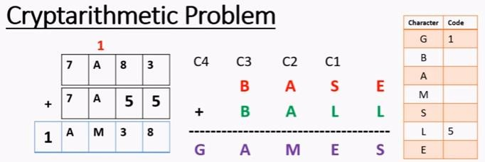

Now Consider (8,3) and B=6
Now Consider (8,3) and B=7 A=4, E=3, S=8,
Since A=4, so M=9

S-E=5
Since C4 is one So Remaining numbers:

L=5 G=1
0,2,3,4,6,7,8,9

Solution Process:

• initial guess m=1 because the sum of two single digits can generate at most a carry '1'.
• When n=1 o=0 or 1 because the largest single digit number added to m=1 can generate the sum of either 0 or 1 depend on the carry received from the carry sum. By this we conclude that o=0 because m is already 1 hence we cannot assign same digit another letter(rule no.)
• We have m=1 and o=0 to get o=0 we have s=8 or 9, again depending on the carry received from the earlier sum.

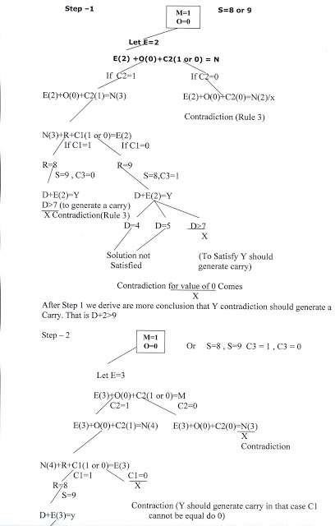

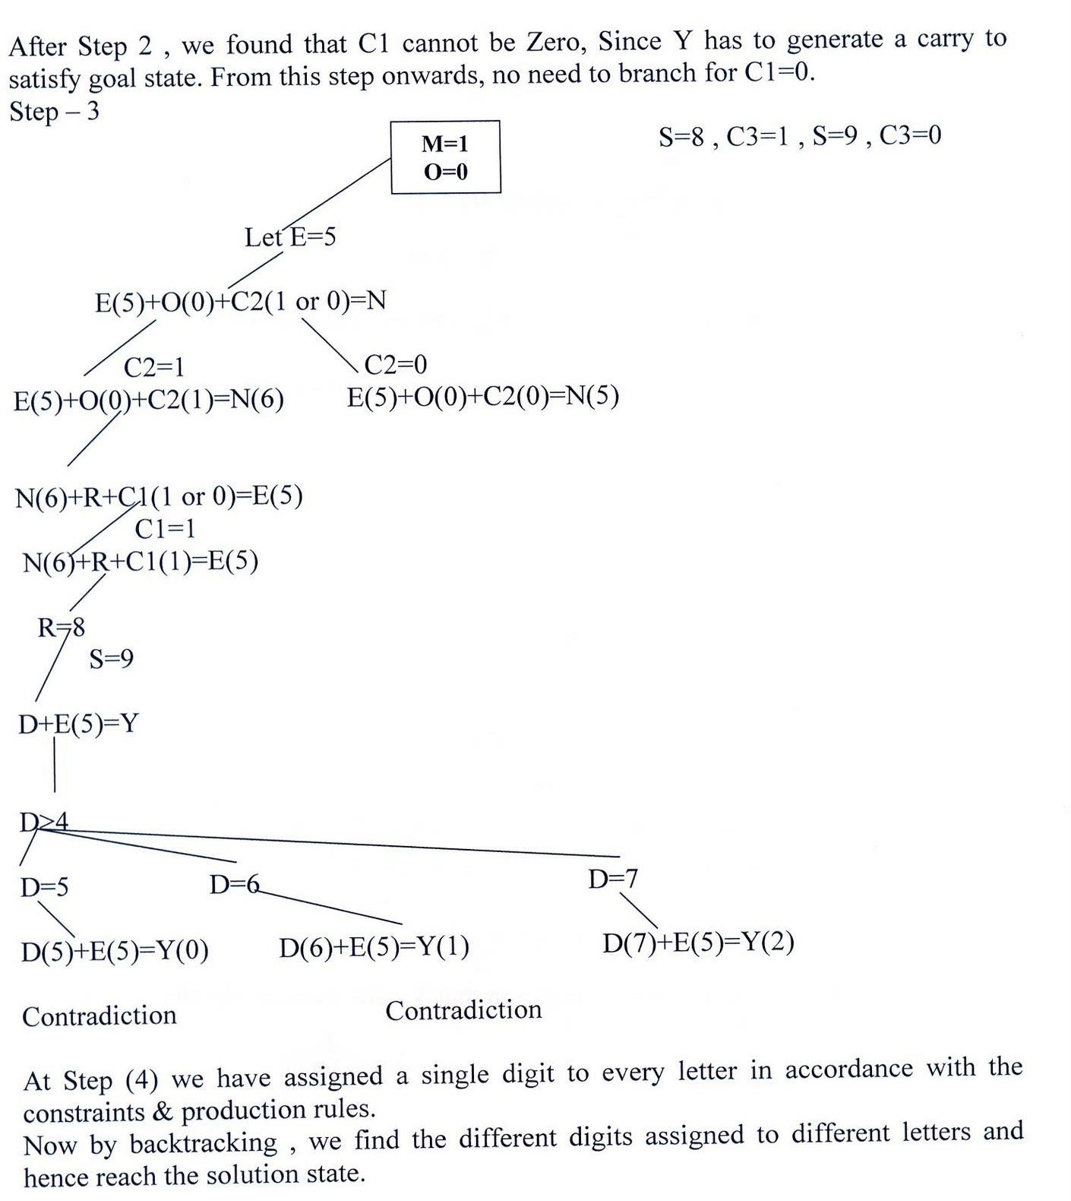

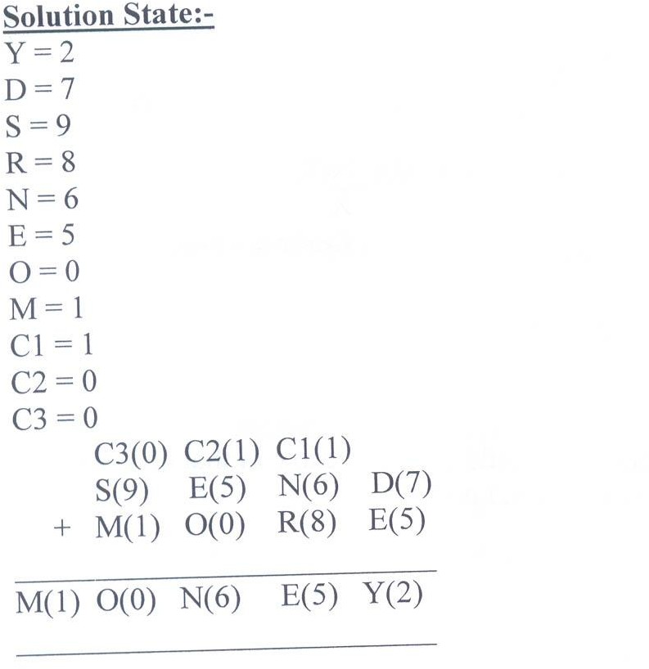

Means-Ends Analysis
- Most of the search strategies either reason forward or backward
however, often a mixture of the two directions is appropriate.
- Such mixed strategy would make it possible to solve the major parts of problem first and solve the smaller problems that arise when combining them together.
- Such a technique is called "Means - Ends Analysis".
- The means-ends analysis process centers around finding the difference between current state and goal state.
- The problem space of means - ends analysis has an initial state and one or more goal state, a set of operaters with a set of preconditions their application and difference functions that computes the difference between two state a(i) and s(j).
- A problem is solved using means – ends analysis

Algorithm for Means-Ends Analysis:
- Let's take a Current state as CURRENT and Goal State as GOAL, then
following are the steps for the MEA algorithm.
- Step 1: Compare CURRENT to GOAL, if there are no differences between both then return Success and Exit.
- Step 2: Else, select the most significant difference and reduce it by doing
the following steps until the success or failure occurs.
  - Select a new operator O which is applicable for the current difference, and if there is no such operator, then signal failure.
  - Attempt to apply operator O to CURRENT. Make a description of two
states.
  - O-Start, a state in which O?s preconditions are satisfied.
  - O-Result, the state that would result if O were applied In O-start.
  - If
(First-Part <------ MEA (CURRENT, O-START)
And
(LAST-Part <----- MEA (O-Result, GOAL), are successful, then signal Success and return the result of combining FIRST-PART, O, and LAST-PART.

Example of Mean-Ends Analysis:

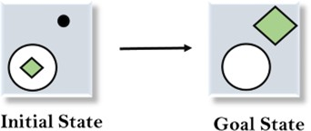

Solution:
To solve the above problem, we will first find the differences between initial states and goal states, and for each difference, we will generate a new state and will apply the operators. The operators we have for this problem are: Move

Delete
Expand


- 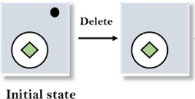Evaluating the initial state: 2. Applying Delete operator

  - Applying Move Operator:
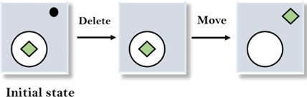

  - Applying Expand Operator:

